

First and Last Name
Student number: Adil Shahzad
Field of study: Computer Science

Thesis Title: Buy & Sell Store

Master’s thesis
written in the Department of Geometry
Supervisor: dr Adam Bartoszek

Łódź 2024
Spis treści
1 Programming tools 5
2 Source code file structure 6
3 Code documentation 7
3.1 First part of code 7
3.2 Next part of code 7
4 Data base 8
5 Project creation documentation 9
5.1 What I do 9
5.2 What I do 9
5.3 What I do 9
6 User documentation 10
7 Bibliography 11
7.1 Books 11
7.2 Articles in professional journals 11
7.3 Internet knowledge sources 11
8 Resources 12

Introduction
Application data

Internet address where the application is available:
Information (identifiers, passwords, etc.) needed to run all parts of the application:

Programming tools

Source code file structure

1. Directory: Shop-backend”

1.1. File: index.js”

1.1.1. Function: checkMongoConnection
In this function we are checking database is connected or not.

1.1.2. Function: verifyJWT
Middleware function to verify JSON Web Tokens (JWT) for authentication purposes.
1.1.3. Function: run
Function to initialize and run the server, including setting up routes, connecting to MongoDB, and handling HTTP requests.
1.1.4. Function: verifyAdmin
Middleware function to verify if the user is an admin based on their role in the database.
1.1.5. Function: verifySeller
Middleware function to verify if the user is a seller based on their role in the database.
1.1.6. Function: app.get("/jwt")
Route to generate and return a JWT token for a given user email.
1.1.7. Function: app.get("/categories")
Route to retrieve all categories from the database.
1.1.7. Function: app.get("/categories")
Route to retrieve all categories from the database.
1.1.8. Function: app.get("/categories/:name")
Route to retrieve books belonging to a specific category.
1.1.9. Function: app.get("/booksAd")
Route to retrieve advertised items from the database
1.1.10. Function: app.get("/books/reported")
Route to retrieve reported items from the database.
1.1.11. Function: app.delete("/books/reported/:id")
Route to delete a reported items from the database.
1.1.12. Function: app.get('/bookGenre')
Route to retrieve genres of books from the database.
1.1.13. Function: app.get('/advertiseBooks'):
Route to retrieve advertised books limited to 10 from the database.
1.1.14. Function: app.post('/books')
Route to add a new book to the database, with verification of JWT and seller roles.
1.1.15. Function: app.post("/users")
Route to add a new user to the database.
1.1.16. Function: app.get("/users/seller/:email")
Route to check if a user is a seller based on their email.
1.1.17. Function: app.get("/users/admin/:email")
Route to check if a user is an admin based on their email.
1.1.18. Function: app.get("/sellers")
Route to retrieve all sellers from the database, with verification of JWT and admin roles.
1.1.19. Function: app.delete('/sellers/:id'):
Route to delete a seller from the database, with verification of JWT and admin roles.
1.1.20. Function: app.put('/sellers/:id')
Route to update a seller's verification status in the database, with verification of JWT and admin roles.
1.1.21. Function: app.get("/buyers")
Route to retrieve all buyers from the database, with verification of JWT and admin roles.
1.1.22. Function: app.delete('/buyers/:id')
Route to delete a buyer from the database, with verification of JWT and admin roles.
1.1.23. Function: app.get('/bookings/:email')
Route to retrieve bookings associated with a specific email.
1.1.24. Function: app.get('/books/:email')
Route to retrieve books associated with a specific seller's email.
1.1.25. Function: app.delete('/books/:id')
Route to delete a book from the database.
1.1.26. Function: app.put('/books/:id')
Route to update a book's advertisement status in the database, with verification of JWT and seller roles.
1.1.27. Function: app.post('/create-payment-intent')
Route to create a payment intent for booking transactions.
1.1.28. Function: app.post('/payments')
Route to handle payment transactions and update booking and book status in the database.
1.1.29. Function: app.get('/payment/:id')
Route to retrieve payment details associated with a specific booking ID.
1.1.30. Function: app.post("/bookings")
Route to add a new booking to the database.
1.1.31. Function: app.put("/books/report/:id")
Route to update a book's reported status in the database.

2. Directory: shop-frontend”
2.1. File: src\Pages\Authentication\Login.js”

2.1.1. Function: Login
Functional component representing the login page. It contains state variables for user email, login email, and error messages. It also includes hooks like useContext, useState, useEffect, and useLocation for managing state and performing side effects.
2.1.2. Function: getAuth
Function from Firebase authentication SDK used to initialize the authentication service.
2.1.3. Function: sendPasswordResetEmail
Function from Firebase authentication SDK used to send a password reset email to the specified email address.
2.1.4. Function: handleEmailBlur
Triggered when the email input field loses focus, updates the state with the entered email.

2.2. File: src\Pages\Authentication\Register.js”
2.2.1. Function: createUser
Function obtained from the AuthContext used to create a new user account.
2.2.2. Function: updateUser
Function obtained from the AuthContext used to update user profile information.
2.2.3. Function: googleLogin
Function obtained from the AuthContext used for Google login.

2.2.4. Function: handleSubmit
Handles form submission for user registration, collects form data, creates a user account, updates user profile, and saves user data to the backend.
2.2.5. Function: handleGoogleUser
Handles Google user login, retrieves user information, and saves user data to the backend.

2.2.6. Function: saveUser
Saves user data (name, email, photo, role) to the backend.

2.3. File: src\Pages\Blog\Blog.js”
2.2.1. Function: Blog
Functional component that is simple blog page with developer information and contact details.

2.3. File: src\Pages\Blog\Blog.js”
2.3.1. Function: Blog
Functional component that represents a simple blog page with developer information and contact details.
2.4. File: src\Pages\Dashboard\Admin\AdminNav\AdminNav.js”
2.4.1. Function: AdminNav
Functional component representing the navigation menu for the admin dashboard. It includes links to different sections of the dashboard such as all sellers, all buyers, and reported items.
2.5. File: src\Pages\Dashboard\Admin\AllBuyers\AllBuyers.js
2.5.1. Function: Booking
- Functional component representing a booking form.
- Allows users to submit their booking details including name, email, phone number, and meeting place.
- Handles form submission to make a booking request.
- Provides a cancel button to close the booking form modal.
- Uses context to access user authentication information.
2.5.2. Function: AllBuyers
- Functional component displaying a list of all buyers.
- Fetches buyer data from an API endpoint using useQuery from @tanstack/react-query.
- Allows administrators to delete buyers from the list.
- Provides feedback to the user through toast notifications for successful deletion.
- Displays a message if no buyers are found or if the data is still loading.

2.6. File: src\Pages\Dashboard\Admin\AllSellers\AllSellers.js
2.6.1. Function: handleDelete
- A function responsible for deleting a seller from the list.
- Sends a DELETE request to the backend API endpoint for deleting a seller.
- Updates the UI by re-fetching the seller list after successful deletion.
- Displays a success toast notification upon successful deletion.

2.6.2. Function: handleVerify
- A function responsible for verifying a seller.
- Sends a PUT request to the backend API endpoint to mark a seller as verified.
- Updates the UI by refetching the seller list after successful verification.
- Displays a success toast notification upon successful verification.

2.6.3. Function: AllSellers
- Functional component displaying a list of all sellers.
- Fetches seller data from an API endpoint using useQuery from @tanstack/react-query.
- Allows administrators to verify or delete sellers from the list.
- Provides feedback to the user through toast notifications for successful actions.
- Displays loading indicator if data is still loading.
- Displays a message if no sellers are found.
2.7. File: src\Pages\Dashboard\Admin\ReportAdmin\ReportAdmin.js
2.7.1. Function: handleDelete
- A function responsible for deleting a reported item from the list.
- Sends a DELETE request to the backend API endpoint for deleting a reported item.
- Updates the UI by re-fetching the reported items list after successful deletion.
- Displays a success toast notification upon successful deletion.
2.7.2. Function: ReportAdmin
- Functional component displaying a list of reported items.
- Fetches reported item data from an API endpoint using useQuery from @tanstack/react-query.
- Allows administrators to delete reported items from the list.
- Provides feedback to the user through toast notifications for successful actions.
- Displays loading indicator if data is still loading.
- Displays a message if no reported items are found.

Code documentation

Pages

Login.js
Importing dependencies and defining the Login component:
In this part, necessary dependencies are imported, including React hooks and functions from external libraries such as Firebase for authentication and react-toastify for displaying toast messages. The Login component is defined as a functional component. Context is used to access authentication-related functions and data. State variables are initialized using the useState hook to manage user input and error messages. The useToken custom hook is used to handle authentication tokens. The useEffect hook is used to navigate the user to the appropriate page after successful login.
const Login = () => {
const { logIn, googleLogin } = useContext(AuthContext)
const [userEmail, setUserEmail] = useState('')
const [loginEmail, setLoginEmail] = useState('')

const [error, setError] = useState()
const [token] = useToken(loginEmail)
const navigate = useNavigate()
const location = useLocation()

const from = location.state?.from?.pathname || '/'

useEffect(() => {
if (token) {
navigate(from, { replace: true });
}
}, [token, from, navigate]);

Handling form submission and password reset:
This part contains event handlers for form submission and email input blur. The handleSubmit function is triggered when the login form is submitted. It extracts the email and password from the form, attempts to log in the user using the provided credentials, and stores the access token in local storage upon successful login. Any errors encountered during login are handled and displayed to the user. The handleEmailBlur function updates the userEmail state variable when the email input field loses focus. The handleReset function is responsible for initiating the password reset process. It checks if the userEmail state is empty and displays an error message if necessary. If an email is provided, it sends a password reset email to the user and displays a success message.
const handleSubmit = (data) => {
data.preventDefault()
const form = data.target;
const email = form.email.value;
const password = form.password.value;

logIn(email, password)
.then(result => {
console.log("resulttttt", result)
const user = result.user;
console.log(user);
setLoginEmail(email);
localStorage.setItem('bookToken',user.accessToken )

})
.catch(error => {
console.log(error.message)
setError(error.message);
})
}

const handleEmailBlur = event => {
const email = event.target.value;
setUserEmail(email)
console.log(email);
}

const handleReset = () => {

if (!userEmail) {
toast.error('Please enter your email first!')
return;
}

sendPasswordResetEmail(auth, userEmail)
.then(() => {
toast.success("Please check your email for password reset link")
})
.catch(er => {
console.log(er);
})
}

Register.js
Form Submission Handling:
This part of the code contains the handleSubmit function, which is responsible for handling form submission when a user registers. Upon form submission, the function extracts the user's input data such as name, email, photo, password, and role. It then creates a FormData object to append the user's photo and sends it to an image hosting service using a fetch request. After successfully uploading the photo, the function creates a new user account by invoking the createUser function with the provided email and password. Upon successful user creation, the updateUser function updates the user's display name and photo URL.
const Register = () => {
const { user, createUser, updateUser, googleLogin } = useContext(AuthContext)
const [saveAs, setSaveAs] = useState('Buyer')
const [createEmail, setCreateEmail] = useState('')
const [token] = useToken(createEmail)
const navigate = useNavigate()
if (token) {
navigate('/')
}
// handle submit
const handleSubmit = (e) => {
e.preventDefault()
const form = e.target;
const name = form.name.value;
const email = form.email.value;
const photof = form.photo.files[0];
const password = form.password.value;
const role = form.role.value;
console.log(name, email, photof, password, role)
const formData = new FormData()
formData.append('image', photof)
const url = `https://api.imgbb.com/1/upload?key=9a88f36ee151409dfaa8048690efbeee`
fetch(url, {
method: "POST",
body: formData
})
.then(res => res.json())
.then(data => {
const photo = data.data.display_url;
// create user
createUser(email, password)
.then(res => {
const user = res.user;
console.log(user)
setSaveAs('Buyer')
// update user
const profile = {
displayName: name,
photoURL: photo
}
updateUser(profile)
.then(() => {
alert("Update")
saveUser(name, email, photo, role)
})
.catch(er => console.error(er))
})
.catch(er => console.error(er))
})
.catch(er => console.error(er))
}

Google Login and User Saving:
This part of the code handles Google login functionality. When a user chooses to register using their Google account, the handleGoogleUser function is invoked. It triggers the googleLogin function provided by the AuthContext. Upon successful login, the saveUser function is called to save the user's information to the backend server. The saveUser function sends a POST request to the server with the user's name, email, photo, and role.
// google login
const handleGoogleUser = () => {
googleLogin()
.then(res => {
const user = res.user;
// saveUser
saveUser(user.displayName, user.email, user.photoURL, saveAs)
})
.catch(er => console.error(er))
}
const saveUser = (name, email, photo, role) => {
const user = { name, email, photo, role }
fetch("https://shop-backend-sigma.vercel.app/users", {
method: "POST",
headers: {
"content-type": "application/json",
authorization: `bearer ${localStorage.getItem("bookToken")}`
},
body: JSON.stringify(user)
})
.then(res => res.json())
.then(data => {
console.log(data)
setCreateEmail(email)
})
}

Blog.js
The Blog component represents a simple webpage section displaying information about the blog's developer. It includes contact details such as email and mobile number. This component is likely used as a static page or footer section in a blog or website developed by developer.
const Blog = () => {
return (
<div className='py-24 pb-56 w-5/6 mx-auto'>
<div className='text-center'>
<div className="card bg-base-100 shadow-xl">
<div className="card-body">
<h2 className="text-center font-bold text-xl"> Developed by Adil Shahzad</h2>
<div>
<p>Contact</p>
<p> Email: adilshahzad684@gmail.com <br />
Mobile: +48-576227792 <br />
Thanks for visiting :)</p>
</div>
</div>
</div>
</div>
</div>
);
};
export default Blog;

Book.js
This code defines a Book component that reports a book when invoked. It sends a request to the backend API to report the book by its ID. The component extracts various details about the book, such as its name, author, image, prices, location, and verification status.
const Book = ({ book, setModalBook }) => {

const handleReport = (id) => {
console.log(id)
fetch(`https://shop-backend-sigma.vercel.app/books/report/${id}`, {
method: "PUT",
headers: {
"content-type": 'application/json',
authorization: `bearer ${localStorage.getItem("bookToken")}`
}
})
.then(res => res.json())
.then(data => {
console.log(data)
toast.success("Reported Successfully !")
})
}
// console.log(book)
const { name, author, img, originalPrice, resalePrice, location, verify, post, sellerName, summery, yearOfUse, yearOfPurchase } = book

Booking.js
This code defines a Booking component that allows users to make a booking for a book. It extracts information about the book from its props and the current user from the authentication context. When the user submits the booking form, it sends a POST request to the backend API with the booking details, including the location, phone number, buyer name, email, book details, and price. Upon successful booking, it closes the booking modal and displays a success message. There's also a function to handle canceling the booking.
const Booking = ({ book, setModalBook }) => {
const { user } = useContext(AuthContext)
console.log(user.displayName)
const { name, author, img, originalPrice, resalePrice, status, location, post, sellerName, summery, yearOfUse, yearOfPurchase, sellerEmail } = book
console.log(book)
const handleSubmit = (e) => {
e.preventDefault()
const form = e.target;
const location = form.place.value;
const phone = form.phone.value;
const buyerName = user.displayName;
const booking = { location, sellerName, phone, img, status, sellerEmail, buyerName, buyerEmail: user.email, book: name, price: resalePrice }
fetch("https://shop-backend-sigma.vercel.app/bookings", {
method: "POST",
headers: {
"content-type": "application/json",
authorization: `bearer ${localStorage.getItem("bookToken")}`
},
body: JSON.stringify(booking)
})
.then(res => res.json())
.then(data => {
console.log(data)
setModalBook(null)
toast.success("Booking Successful!")
})
}
const handleCancel = () => {
setModalBook(null)
}

Books.js
This page component, Books, displays a collection of books. It retrieves the book data using the useLoaderData hook. Each book is rendered using the Book component, and the component manages a modal for booking a selected book using the Booking component. Users can interact with the books and initiate bookings through the modal. The layout is designed to display two books per row with a gap between them.
const Books = () => {
const books=useLoaderData()
const[modalBook,setModalBook]=useState(null)
// console.log(books)
return (
<div className='md:grid grid-cols-2 gap-20 w-3/4 mx-auto my-12'>
{
books.map(book=><Book book={book} modalBook={modalBook} setModalBook={setModalBook} key={book._id}></Book>)
}
{
modalBook &&
<Booking book={modalBook} setModalBook={setModalBook}></Booking>
}
</div>
);
};
export default Books;

AdminNav.js
Defines a component called AdminNav which serves as the navigation menu for an admin dashboard. It includes links to three different sections: "All Sellers", "All Buyers", and "Reported Books". Each link is represented as a list item (<li>) within an unordered list (<ul>) and uses the Link component from React Router to navigate to the respective sections. Additionally, each link is accompanied by an icon from either FaHandHoldingUsd, FaHandHoldingHeart, or MdReport, which are imported from the react-icons library.
const AdminNav = () => {
return (
<div>
<ul className="">
<li className=" font-semibold text-lg">
<Link to="/dashboard/all-seller"><FaHandHoldingUsd></FaHandHoldingUsd>All Sellers</Link>
</li>
<li className=" font-semibold text-lg">
<Link to="/dashboard/all-buyer"><FaHandHoldingHeart></FaHandHoldingHeart>All Buyers</Link>
</li>
<li className=" font-semibold text-lg">
<Link to="/dashboard/reported-items"><MdReport></MdReport>Reported Books</Link>
</li>
</ul>
</div>
);
};
export default AdminNav;

AllBuyers.js
This defines a React component called AllBuyers, which fetches a list of buyers from an API endpoint using the useQuery hook from the react-query library. It then renders a table displaying the names and email addresses of the buyers. Additionally, it provides functionality to delete a buyer from the list, triggering a re-fetch of the data to update the UI accordingly. If there are no buyers or the data is still loading, it displays a message indicating that there are no elements to show.
const AllBuyers = () => {
const { data: buyers = [], refetch, isLoading } = useQuery({
queryKey: ['buyers'],
queryFn: () => fetch('https://shop-backend-sigma.vercel.app/buyers', {
headers: {
authorization: `bearer ${localStorage.getItem("bookToken")}`
}
})
.then(res => res.json())
})
console.log(buyers)
const handleDelete = (id) => {
console.log(id)
fetch(`https://shop-backend-sigma.vercel.app/buyers/${id}`, {
method: "DELETE",
headers: {
authorization: `bearer ${localStorage.getItem("bookToken")}`
}
})
.then(res => res.json())
.then(data => {
console.log(data)
toast.success("Delete Successfully !")
refetch()
})
}
if (isLoading || buyers.length === 0) {
return <NoElements item="Buyers"></NoElements>
}

AllSellers.js
Data Fetching and Mutation Handling:
This part of the code is responsible for fetching data about all the sellers from the backend server and handling mutations such as deleting and verifying seller accounts. It uses the useQuery hook from React Query to fetch data asynchronously. The fetched data is stored in the sellers variable. The handleDelete function sends a DELETE request to the server to delete a specific seller based on their ID. Similarly, the handleVerify function sends a PUT request to verify a seller's account. Both functions trigger a toast notification upon successful completion and then trigger a data refetch to update the seller list.
const AllSellers = () => {
const { data: sellers = [], refetch, isLoading } = useQuery({
queryKey: ['sellers'],
queryFn: () => fetch('https://shop-backend-sigma.vercel.app/sellers', {
headers: {
authorization: `bearer ${localStorage.getItem("bookToken")}`
}
})
.then(res => res.json())
})
console.log(sellers)
const handleDelete = (id) => {
console.log(id)
fetch(`https://shop-backend-sigma.vercel.app/sellers/${id}`, {
method: "DELETE",
headers: {
authorization: `bearer ${localStorage.getItem("bookToken")}`
}
})
.then(res => res.json())
.then(data => {
console.log(data)
toast.success("Delete Successfully !")
refetch()
})
}
const handleVerify = (id) => {
console.log(id)
fetch(`https://shop-backend-sigma.vercel.app/sellers/${id}`, {
method: "PUT",
headers: {
authorization: `bearer ${localStorage.getItem("bookToken")}`
}
})
.then(res => res.json())
.then(data => {
console.log(data)
if (data.modifiedCount > 0) {
toast.success("Verify Successfully !")
refetch()
}
})
}

Loading and Empty State Handling:
This part of the code handles loading and empty state conditions. If the data is still loading, it displays a loading spinner using the BigLoading component. If there are no sellers available, it displays a message indicating that there are no sellers to show using the NoElements component.
if (isLoading) {
return <BigLoading></BigLoading>
}
if (sellers.length < 1) {
return <NoElements item="Sellers"></NoElements>
}

ReportAdmin.js
This defines a React component named AllSellers. It retrieves a list of sellers from a backend API using the useQuery hook provided by the react-query library. It allows users to delete or verify sellers. If the data is still loading, it displays a loading spinner, and if there are no sellers, it displays a message indicating that there are no elements to show.

This part of the code is responsible for fetching data about all the reported items from the backend server and handling the deletion of reported items. It uses the useQuery hook from React Query to fetch data asynchronously. The fetched data is stored in the reportedItems variable. The handleDelete function sends a DELETE request to the server to delete a specific reported item based on its ID. Upon successful deletion, it triggers a toast notification and then refetches the data to update the list of reported items.
const ReportAdmin = () => {

const { data: reportedItems = [], refetch, isLoading } = useQuery({
queryKey: ['reportedItems'],
queryFn: () => fetch('https://shop-backend-sigma.vercel.app/books/reported', {
headers: {

authorization: `bearer ${localStorage.getItem("bookToken")}`
}
})
.then(res => res.json())
})
const handleDelete = (id) => {
console.log(id)
fetch(`https://shop-backend-sigma.vercel.app/books/reported/${id}`, {
method: "DELETE",
headers: {
authorization: `bearer ${localStorage.getItem("bookToken")}`
}
})
.then(res => res.json())
.then(data => {
console.log(data)
if (data.deletedCount > 0) {
toast.success("Delete Successfully !")
refetch()
}
})
}
console.log(reportedItems)

This part of the code handles loading and empty state conditions. If the data is still loading, it displays a loading spinner using the BigLoading component. If there are no reported items available, it displays a message indicating that there are no reported items to show using the NoElements component.

if (isLoading) {
return <BigLoading></BigLoading>
}
if (reportedItems.length < 1) {
return <NoElements item="Reported Items"></NoElements>
}

BuyerNav.js
This code defines a React component named BuyerNav, which represents the navigation menu for buyers. It consists of a list with a single item, "My Orders", which is linked to the "/dashboard/my-orders" route. The item is accompanied by an icon from the react-icons library, specifically FaBookOpen, indicating that it relates to viewing orders.
const BuyerNav = () => {
return (
<div>
<ul className="">
<li className=" font-semibold text-lg">
<Link to="/dashboard/my-orders"><FaBookOpen></FaBookOpen> My Orders</Link>
</li>
</ul>
</div>
);
};
export default BuyerNav;

MyOrders.js
This code defines a React component named MyOrders, which fetches and displays bookings associated with the currently authenticated user. It retrieves booking data from the backend API based on the user's email address and renders it. If there are no bookings or if the data is still loading, it displays a loading indicator or a message indicating no bookings found.
const MyOrders = () => {
const { user } = useContext(AuthContext)
const { data: myBookings = [], refetch, isLoading } = useQuery({
queryKey: ['myBookings'],
queryFn: () => fetch(`https://shop-backend-sigma.vercel.app/bookings/${user?.email}`, {
headers: {

authorization: `bearer ${localStorage.getItem("bookToken")}`
}
})
.then(res => res.json())
})
console.log(myBookings)
if (isLoading) {
return <BigLoading></BigLoading>
}
if (myBookings.length < 1) {
return <NoElements item="Bookings"></NoElements>
}

CheckoutForm.js
State Initialization and Dependencies:

In this section, we initialize state variables necessary for managing the checkout process, such as cardError, success, processing, transactionId, and clientSecret, using the useState hook. These variables are responsible for tracking the status of the payment process and any potential errors that may occur. Additionally, we extract relevant data from the booking prop, including the price, book details, buyer information, and seller information. Furthermore, we import required dependencies from React and Stripe, such as useStripe and useElements, which are essential for integrating with the Stripe payment gateway.
const CheckoutForm = ({ booking }) => {
console.log(booking)
const { price, book, img, buyerName, buyerEmail, location, sellerName, sellerEmail } = booking;
const [cardError, setCardError] = useState('');
const [success, setSuccess] = useState('');
const [processing, setProcessing] = useState(false);
const [transactionId, setTransactionId] = useState('');
const [clientSecret, setClientSecret] = useState("");
useEffect(() => {
// Create PaymentIntent as soon as the page loads
fetch("https://shop-backend-sigma.vercel.app/create-payment-intent", {
method: "POST",
headers: {
"Content-Type": "application/json",
authorization: `bearer ${localStorage.getItem('bookToken')}`
},
body: JSON.stringify({ price }),
})
.then((res) => res.json())
.then((data) => setClientSecret(data.clientSecret));
}, [price]);
const stripe = useStripe();
const elements = useElements();

Payment Intent Creation:
This section focuses on the creation of a payment intent, a crucial step in the checkout process. We utilize the useEffect hook to trigger the creation of a payment intent as soon as the page loads. This involves making a POST request to the backend server, specifically to the /create-payment-intent endpoint, with the price of the booked item. Upon receiving a response from the server, we extract the client secret from the data and update the clientSecret state variable accordingly. This client secret is required by Stripe to authenticate and process the payment.

useEffect(() => {
// Create PaymentIntent as soon as the page loads
fetch("https://shop-backend-sigma.vercel.app/create-payment-intent", {
method: "POST",
headers: {
"Content-Type": "application/json",
authorization: `bearer ${localStorage.getItem('bookToken')}`
},
body: JSON.stringify({ price }),
})
.then((res) => res.json())
.then((data) => setClientSecret(data.clientSecret));
}, [price]);

Form Submission and Payment Processing:

In this part, we define the handleSubmit function, which handles the submission of the checkout form and initiates the payment processing. When the form is submitted, this function is invoked. First, it checks if the necessary Stripe elements are available for processing the payment. If not, it returns early. Next, it retrieves the card information using elements.getElement(CardElement) and creates a payment method with Stripe using stripe.createPaymentMethod. The function then proceeds to confirm the payment with Stripe's stripe.confirmCardPayment method, passing the client secret and additional payment details. Upon receiving a response, it checks for any errors or confirmations. If there are errors, it updates the cardError state variable with the error message. If the payment is successful, it updates the success state variable, stores the transaction ID, and saves the payment details to the backend server. Finally, it sets the processing state variable to false to indicate the completion of the payment process.

const handleSubmit = async (e) => {
e.preventDefault()
if (!stripe || !elements) {
return;
}
const card = elements.getElement(CardElement);

if (card == null) {
return;
}
const { error, paymentMethod } = await stripe.createPaymentMethod({
type: 'card',
card,
});
if (error) {
console.log(error);
setCardError(error.message);
}
else {
setCardError('');
}
setSuccess('');
setProcessing(true);
const { paymentIntent, error: confirmError } = await stripe.confirmCardPayment(
clientSecret,
{
payment_method: {
card: card,
billing_details: {
name: buyerName,
email: buyerEmail
},
},
},
);
if (confirmError) {
setCardError(confirmError.message);
return;
}
if (paymentIntent.status === "succeeded") {
console.log('card info', card);
// store payment info in the database
const payment = {
price,
book,
transactionId: paymentIntent.id,
buyerEmail,
sellerEmail: sellerEmail,
bookingId: booking._id
}
fetch('https://shop-backend-sigma.vercel.app/payments', {
method: 'POST',
headers: {
'content-type': 'application/json',
authorization: `bearer ${localStorage.getItem('bookToken')}`
},
body: JSON.stringify(payment)
})
.then(res => res.json())
.then(data => {
console.log(data);
if (data.insertedId) {
setSuccess('Congrats! your payment completed');
setTransactionId(paymentIntent.id);
toast.success("Payment Successfull !")
}
})
}
setProcessing(false)
}

Payment.js
This page is a React component called Payment, responsible for handling payment processing. It receives booking details as props, including the price, book information, buyer details, and seller details. The component renders a form to facilitate payment using Stripe. It uses the Elements component from the react-stripe-js library to integrate with Stripe's payment elements. The CheckoutForm component is passed the booking details to initiate the payment process.
const stripePromise = loadStripe("pk_test_51OpSpzH3E5J344FHjABIE8KGLF13ng0p2ZrBB8FCAra9JZjdxvZLNwEV2Cd08iLdeJ2lX1WtTn5BZareXupEkPM000PCj4fITT");
const Payment = () => {
const booking = useLoaderData();
console.log(stripePromise)
console.log(booking)
const { price,book,img,buyerName,buyerEmail,location,sellerName} = booking;
return (
<div className='text-center mt-16 p-2'>
<h3 className="text-3xl">Payment for {book}</h3>
{/* <p className="text-xl">Please pay <strong>${price}</strong> for your appointment on {appointmentDate} at {slot}</p> */}
<div className='w-96 my-12 mx-auto'>
<Elements stripe={stripePromise}>
<CheckoutForm
booking={booking}
/>
</Elements>
</div>
</div>
);
};
export default Payment;

NoElements.js
This page component, NoElements, is designed to display a message when there are no items available for a particular category. It receives the name of the item as a prop and renders a message indicating that there are no items of that category available. The message is styled to be prominently displayed in the center of the screen.
const NoElements = ({item}) => {
return (
<div className='flex justify-center items-center h-screen '>
<h2 className='md:text-7xl text-primary font-bold'>No {item} Available</h2>
</div>
);
};
export default NoElements;

AddProduct.js
The AddProduct page allows authenticated users to add new products to the platform. It presents a form where users can input details such as product name, description, prices, condition, location, and genre. Upon submission, the form uploads the product image to an image hosting service, retrieves the image URL, and sends the product data along with the image URL to the backend for storage. If the addition is successful, the user is redirected to their product dashboard.
const AddProduct = () => {
const { user } = useContext(AuthContext)
const navigate = useNavigate()
const { data: categories = [] } = useQuery({
queryKey: ['categories'],
queryFn: () => fetch('https://shop-backend-sigma.vercel.app/bookGenre')
.then(res => res.json())
})
const handleSubmit = (e) => {
e.preventDefault()
const form = e.target;
const name = form.product.value;
const summery = form.des.value;
const resalePrice = form.resalePrice.value;
const originalPrice = form.originalPrice.value;
const yearOfUse = form.yearOfUse.value;
const yearOfPurchase = form.yearOfPurchase.value;
const sellerName = user?.displayName;
const sellerEmail = user.email;
const condition = form.condition.vale;
const location = form.place.value;
const sellerPhone = form.phone.value;
const genre = form.genre.value;
const image = form.photo.files[0]
const status = "Available"
const formData = new FormData()
formData.append('image', image)
const url = `https://api.imgbb.com/1/upload?key=9a88f36ee151409dfaa8048690efbeee`
console.log("urlllll", url)
fetch(url, {
method: "POST",
body: formData
})
.then(res => res.json())
.then(data => {
console.log(data)
const img = data?.data?.display_url;
const product = { name, status, summery, resalePrice, originalPrice, yearOfPurchase, yearOfUse, sellerEmail, sellerName, sellerPhone, img, condition, location, genre }
fetch('https://shop-backend-sigma.vercel.app/books', {
method: "POST",
headers: {
"content-type": "application/json",
authorization: `bearer ${localStorage.getItem("bookToken")}`
},
body: JSON.stringify(product)
})
.then(res => res.json())
.then(data => {
console.log(data)
if (data.acknowledged) {
toast.success("Added Successfully !")
navigate('/dashboard/myproduct')
}
})
})
}

MyBuyers.js
The MyBuyers page displays a list of buyers who have made bookings associated with the authenticated user. It fetches data from the backend API to retrieve the list of buyers based on the user's email. If data is still loading, a loading indicator is shown. If there are no buyers associated with the user, a message indicating the absence of buyers is displayed. Otherwise, a table is rendered showing details such as the buyer's name, phone number, email address, and location for each buyer.
const MyBuyers = () => {
const { user } = useContext(AuthContext)
const { data: myBuyers = [], refetch, isLoading } = useQuery({
queryKey: ['myBuyers'],
queryFn: () => fetch(`https://shop-backend-sigma.vercel.app/bookings/${user?.email}`, {
headers: {
authorization: `bearer ${localStorage.getItem("bookToken")}`
}
})
.then(res => res.json())
})
if (isLoading) {
return <BigLoading></BigLoading>
}
if (myBuyers.length < 1) {
return <NoElements item="Buyers"></NoElements>
}

MyProducts.js
The MyProducts page allows authenticated users to view and manage their listed products. It fetches data from the backend API to retrieve the user's products based on their email. The page displays the user's products in a list format. Users can delete their products by clicking on a delete button associated with each product. Additionally, users can mark their products as advertised, triggering an update in the backend. If data is still loading, a loading indicator is shown, and if there are no products listed, a message indicating the absence of products is displayed.
const MyProducts = () => {
const { user } = useContext(AuthContext)
const { data: myProducts = [], refetch, isLoading } = useQuery({
queryKey: ['myProducts'],
queryFn: () => fetch(`https://shop-backend-sigma.vercel.app/books/${user?.email}`)
.then(res => res.json())
})
console.log(myProducts)
// delete
const handleDelete = (id) => {
console.log(id)
fetch(`https://shop-backend-sigma.vercel.app/books/${id}`, {
method: "DELETE",
headers: {
authorization: `bearer ${localStorage.getItem("bookToken")}`
}
})
.then(res => res.json())
.then(data => {
console.log(data)
refetch()
})
}
// advertise
const handleAdvertise = (id) => {
console.log(id)
fetch(`https://shop-backend-sigma.vercel.app/books/${id}`, {
method: "PUT",
headers: {
authorization: `bearer ${localStorage.getItem("bookToken")}`
}
})
.then(res => res.json())
.then(data => {
if (data.modifiedCount) {
console.log(data)
refetch()
toast.success("Advertise Successfully !")
}
})
}
if (isLoading) {
return <BigLoading></BigLoading>
}
if (myProducts.length < 1) {
return <NoElements item="Products"></NoElements>
}

SellerNav.js
The SellerNav component represents the navigation bar for sellers within the dashboard. It provides links to essential sections for sellers, including adding a new product, managing their existing products, and viewing their buyers. Each link is accompanied by an icon representing its respective section.
const SellerNav = () => {
return (
<div>
<ul className="">
<li className=" font-semibold text-lg">
<Link to="/dashboard/addproduct"><GiBookCover></GiBookCover>Add A Product</Link>
</li>
<li className=" font-semibold text-lg">
<Link to="/dashboard/myproduct"><GiBookPile></GiBookPile>My Products</Link>
</li>
<li className=" font-semibold text-lg">
<Link to="/dashboard/mybuyer"><FaUserAlt></FaUserAlt>My Buyers</Link>
</li>

</ul>
</div>
);
};

export default SellerNav;

Sidebar.js
The Sidebar component serves as the sidebar navigation for the dashboard. It includes branding information and profile details of the logged-in user, such as their name and email, along with their profile picture. Additionally, it dynamically renders different navigation sections based on the user's role. If the user is identified as a seller, it displays navigation links for seller-specific actions. If the user is an admin, it shows navigation links for admin-specific actions. Otherwise, it displays navigation links for general buyer actions. This component provides a seamless and personalized dashboard experience based on the user's role.
const Sidebar = () => {
const { user, logout } = useContext(AuthContext)
const [isSeller] = useSeller(user?.email)
const [isAdmin] = useAdmin(user?.email)
return (
<div>
{/* Branding & Profile Info */}
<div className=''>
<h2 className='text-3xl cursor-pointer font-semibold text-center text-primary '>
<Link to='/'>Buy & Sell</Link>
</h2>
<div className='flex flex-col items-center mt-6 -mx-2'>
<Link to='/dashboard'>
<img
className='object-cover w-24 h-24 mx-2 my-6 rounded-full'
src={user?.photoURL}
alt='avatar'
referrerPolicy='no-referrer'/>
</Link>
<Link to='/dashboard'>
<h4 className='mx-2 mt-2 font-medium text-primary text-xl hover:underline'>
{user?.displayName} {isAdmin && !isSeller ? "(Admin)": isSeller && !isAdmin ? "(Seller)" : " (Buyer)"}
</h4>
</Link>
<Link to='/dashboard'>
<p className='mx-2 mt-1 text-sm font-medium text-primary hover:underline'>
{user?.email}
</p>
</Link>
</div>
</div>
{/* Nav Items */}
<div className='flex flex-col justify-between flex-1 mt-6'>
<nav>
{
isSeller && !isAdmin && <SellerNav></SellerNav>
}
{
isAdmin && !isSeller && <AdminNav></AdminNav>
}
{
!isAdmin && !isSeller && <BuyerNav></BuyerNav>
}
</nav>
</div>
</div>
);
};
export default Sidebar;

AdvertiseItem.js
This defines a component called AdvertiseItem, which takes an advertiseItem object as a prop. It destructures properties like name, img, resalePrice, originalPrice, author, and summery from the advertiseItem object. Inside the component, it renders a card with an image, title, author, and a truncated summary of the item. If the summary is longer than 150 characters, it appends "Read More..." at the end.
const AdvertiseItem = ({ advertiseItem }) => {
const { name,img,resalePrice,originalPrice,author,summery } = advertiseItem
return (
<div className="card bg-base-100 shadow-xl">
<figure className="px-10 pt-10">
<img src={img} alt="Shoes" className="rounded-xl h-48" />
</figure>
<div className="card-body items-center text-center">
<div>
<h2 className="card-title font-bold ">{name}</h2>
<small className='text-base text-gray-500'>{author}</small>
</div>
<p>{`${summery.slice(0,150)} Read More...`}</p>

</div>
</div>
);
};

export default AdvertiseItem;

AdvertiseItems.js
This code defines a component called AdvertiseItems, which fetches a collection of advertised books from an API endpoint using the useQuery hook from React Query. Once the data is fetched, it renders a title "Ours Collection" followed by a grid layout displaying the advertised books using the AdvertiseItem component. If the data is not yet available, it returns nothing until the data is fetched.
const AdvertiseItems = () => {
const { data: advertiseItems = [] } = useQuery({
queryKey: ['advertiseItems'],
queryFn: () => fetch('https://shop-backend-sigma.vercel.app/advertiseBooks')
.then(res => res.json())
})
if (advertiseItems) {

return (
<div>
<h2 className='text-primary text-4xl font-semibold text-center my-16'>Ours Collection</h2>
<div className='grid grid-cols-1 lg:grid-cols-3 gap-20'>
{
advertiseItems.map(advertiseItem => <AdvertiseItem key={advertiseItem._id} advertiseItem={advertiseItem}></AdvertiseItem>)
}
</div>
</div>
);
}
};

export default AdvertiseItems;

Categories.js
This page fetches a list of categories from an API endpoint and displays them in a grid layout. It begins by initializing the state variables categories and loading, where categories holds the fetched category data, and loading indicates whether the data is still being loaded or not.
Once the component mounts, it fetches the categories data using fetch and updates the state accordingly. While the data is being fetched, it displays a loading indicator (BigLoading). After the data is loaded, it renders a title "Choose Your Own Category" followed by a grid layout displaying the categories using the Category component. If the loading process encounters an error, it is logged to the console.
const Categories = () => {
const [categories, setCategories] = useState([])
const [loading, setLoading] = useState(true);
useEffect(() => {
fetch('https://shop-backend-sigma.vercel.app/categories')
.then(response => response.json())
.then(data => {
setCategories(data)
setLoading(false);
})
.catch(error => {
console.error(error);
});
}, []);
if (loading) {
return <BigLoading></BigLoading>
}
return (
<div>
<h2 className='text-primary text-4xl font-semibold text-center my-16'>Choose Your Own Category</h2>
<div className='grid grid-cols-1 lg:grid-cols-3 gap-10'>
{
categories.map(category => <Category key={category._id} category={category}></Category>)

}
</div>
</div>
);
};
export default Categories;

Category.js
This page represents a single category card. It takes a category object as a prop, which includes information such as the category's image (img) and genre (genre).
The card displays the category's image followed by the genre name. It also includes a button labeled "See Collections", which redirects the user to a page displaying collections specific to that category when clicked. The button is decorated with a right arrow icon (FaArrowRight) to indicate the action.
const Category = ({ category }) => {
// console.log(category)
return (
<div className="card h-72 bg-base-100 shadow-xl image-full">
<figure><img src={category.img} className='w-full' alt="Shoes" /></figure>
<div className="card-body items-center text-center">
<h2 className="card-title mt-24 text-4xl">{category.genre}</h2>
<Link to={`/categories/${category.genre}`}>
<div className="card-actions justify-end">
<button className="flex items-center text-xl">See Collections <FaArrowRight className=' ml-3'></FaArrowRight></button>
</div>
</Link>
</div>
</div>
);
};
export default Category;

AdminRoute.js
The AdminRoute component is designed to control access to routes specifically for administrators. It utilizes context to access the user's authentication status and the loading state, as well as a custom hook useAdmin to determine if the user has administrative privileges.
During loading or while checking the admin status, it displays a loading indicator. Once the loading is complete, it verifies if the user is authenticated and has administrative privileges. If both conditions are met, it renders the child components (routes). Otherwise, it redirects the user to the login page, preserving the current location for redirection after successful authentication.
const AdminRoute = ({ children }) => {
const { user, loading } = useContext(AuthContext);
const [isAdmin, isAdminLoading] = useAdmin(user?.email);
const location = useLocation();

if (loading || isAdminLoading) {
return <BigLoading></BigLoading>
}

if (user && isAdmin) {
return children;
}

return <Navigate to="/login" state={{ from: location }} replace></Navigate>;
};

export default AdminRoute;

PrivateRoute.js
The PrivateRoute component is responsible for controlling access to routes that require authentication. It utilizes context to access the user's authentication status and loading state.
During the loading phase, it displays a loading indicator. Once the loading is complete, it checks if there is a logged-in user. If there is no user logged in, it redirects the user to the login page, preserving the current location for redirection after successful authentication.
If the user is logged in, it renders the child components (routes), allowing access to the protected content.
const PrivateRoute = ({children}) => {
const {user,loading}=useContext(AuthContext)
const navigate=useNavigate();
const location= useLocation()
if(loading){
return <BigLoading></BigLoading>
}
if(!user){
return <Navigate to='/login' state={{from:location}}></Navigate>
}
return (
<div>
{children}
</div>
);
};

export default PrivateRoute;

SellerRoute.js
The SellerRoute component ensures that only authenticated users who are identified as sellers have access to specific routes within the application. It utilizes React context and custom hooks to determine the user's authentication status and whether they are a seller. If the user is authenticated and identified as a seller, it renders the children components, allowing access to the protected route. Otherwise, it redirects unauthorized users to the login page while preserving the current location information. During the loading phase, it displays a loading indicator.
const SellerRoute = ({ children }) => {
const { user, loading } = useContext(AuthContext);
const [isSeller, isSellerLoading] = useSeller(user?.email);
const location = useLocation();

if (loading || isSellerLoading) {
return <BigLoading></BigLoading>
}

if (user && isSeller) {
return children;
}

return <Navigate to="/login" state={{ from: location }} replace></Navigate>;
};

export default SellerRoute;

Backend

index.js
This code defines an asynchronous function checkMongoConnection that attempts to connect to a MongoDB database using a MongoDB client instance (client). Upon successful connection, it logs a success message and retrieves a list of databases, which is then logged to the console. If an error occurs during the connection attempt, it logs the error. Finally, it includes commented-out code to close the database connection, although it's typically not advisable to close the connection immediately in a real application.
async function checkMongoConnection() {
try {
await client.connect();
console.log('MongoDB connected successfully');
// Example: Print the databases
const databasesList = await client.db().admin().listDatabases();
console.log('Databases:', databasesList.databases);

} catch (error) {
console.error('Error connecting to MongoDB:', error);
} finally {
// Close the connection when done (Note: You might not want to close the connection immediately in a real app)
// await client.close();
}
}

This function verifyJWT is middleware for verifying JSON Web Tokens (JWT) in HTTP requests. It takes req, res, and next parameters, representing the request, response, and next function in the middleware chain, respectively. It checks if the request contains an authorization header, and if not, it returns a 401 status code indicating unauthorized access. If the header exists, it extracts the token, verifies it using a secret key, and if successful, attaches the decoded token to the request (req.decoded) and calls the next middleware function. If verification fails, it returns a 403 status code indicating forbidden access.

function verifyJWT(req, res, next) {

const authHeader = req.headers.authorization;
console.log("authauthauthauthauthauthauth" , authHeader)
if (!authHeader) {
return res.status(401).send('unauthorized access');
}

const token = authHeader.split(' ')[1];

jwt.verify(token,"adil123", function (err, decoded) {
if (err) {
return res.status(403).send({ message: 'forbidden access' })
}
req.decoded = decoded;
next();
})

}
This run function sets up collections for different entities in a MongoDB database (bookCollection, categoriesCollection, usersCollection, bookingsCollection, paymentsCollection). Additionally, it defines a middleware function verifyAdmin, which checks if the decoded email from the request corresponds to an admin user in the database. If the user is not an admin, it returns a 403 status code indicating forbidden access; otherwise, it calls the next middleware function.
async function run() {
try {

const bookCollection = client.db("bookShopDB").collection("books")
const categoriesCollection = client.db("bookShopDB").collection("categories")
const usersCollection = client.db("bookShopDB").collection("users")
const bookingsCollection = client.db("bookShopDB").collection("bookings")
const paymentsCollection = client.db("bookShopDB").collection("payments")

// admin verify
const verifyAdmin = async (req, res, next) => {
const decodedEmail = req.decoded.email;
const query = { email: decodedEmail };
const user = await usersCollection.findOne(query);

if (user?.role !== 'Admin') {
return res.status(403).send({ message: 'forbidden access' })
}
next();
}

The code consists of two parts:
verifySeller is a middleware function that checks if the decoded email from the request corresponds to a seller user in the database. If the user is not a seller, it returns a 403 status code indicating forbidden access; otherwise, it calls the next middleware function.
A route handler for the endpoint /jwt is defined using app.get. This handler expects an email query parameter. It queries the database for a user with the provided email and generates a JWT (JSON Web Token) with the email payload if the user exists. The JWT is signed using a secret key and sent back to the client as bookToken. If the user does not exist, it returns a 403 status code with an empty bookToken.
const verifySeller = async (req, res, next) => {
const decodedEmail = req.decoded.email;
const query = { email: decodedEmail };
const user = await usersCollection.findOne(query);

if (user?.role !== 'Seller') {
return res.status(403).send({ message: 'forbidden access' })
}
next();
}
app.get("/jwt", async (req, res) => {
console.log("hererrereeeeeee")
const email = req.query.email;
const query = { email: email };
const user = await usersCollection.findOne(query);
console.log("useruseruseruseruser", user)
if (user) {
const token = jwt.sign({ email },"adil123", { expiresIn: "1d" })
console.log(token)
res.send({ bookToken: token })
}

else {
res.status(403).send({ bookToken: "" })
}
})

This part of code defines two endpoints for handling category-related requests:
The first endpoint /categories responds with a list of all categories available in the database. It retrieves categories from the categoriesCollection and sends them back as a response.
The second endpoint /categories/:name responds with a list of books belonging to a specific category identified by its name. It first extracts the category name from the request parameters, then queries the bookCollection for books matching the provided category name and having a status of "Available". Finally, it sends the list of books back as a response.
app.get("/categories", async (req, res) => {
const query = {}
const categories = await categoriesCollection.find(query).toArray()

res.send(categories)
})
app.get("/categories/:name", async (req, res) => {
const genre = req.params.name;
console.log(genre)
const query = { genre: genre, status: "Available" }
const books = await bookCollection.find(query).toArray()
console.log(books)

res.send(books)
})

This part of code defines two endpoints:
The first endpoint /sellers responds with a list of all users who have the role "Seller". It verifies the JWT token and admin access before processing the request. It queries the usersCollection for users with the role "Seller" and sends them back as a response.
The second endpoint DELETE /sellers/:id deletes a seller with the specified ID. It also requires JWT verification and admin access. It extracts the ID from the request parameters, then deletes the seller with that ID from the usersCollection. Finally, it sends the deletion result back as a response.

app.get("/sellers", verifyJWT, verifyAdmin, async (req, res) => {

const query = { role: "Seller" }
const sellers = await usersCollection.find(query).toArray()

console.log(sellers)
res.send(sellers)
})

app.delete('/sellers/:id', verifyJWT, verifyAdmin, async (req, res) => {
const id = req.params.id;
const query = { _id: ObjectId(id) }
const result = await usersCollection.deleteOne(query)
console.log(result)
res.send(result)
})

This part of code sets up two API endpoints:
The first endpoint /buyers responds with a list of all users who have the role "Buyer". It verifies the JWT token and admin access before processing the request. It queries the usersCollection for users with the role "Buyer" and sends them back as a response.
The second endpoint DELETE /buyers/:id deletes a buyer with the specified ID. It also requires JWT verification and admin access. It extracts the ID from the request parameters, then deletes the buyer with that ID from the usersCollection. Finally, it sends the deletion result back as a response.

app.get("/buyers", verifyJWT, verifyAdmin, async (req, res) => {

const query = { role: "Buyer" }
const sellers = await usersCollection.find(query).toArray()

console.log(sellers)
res.send(sellers)
})

app.delete('/buyers/:id', verifyJWT, verifyAdmin, async (req, res) => {
const id = req.params.id;
const query = { _id: ObjectId(id) }
const result = await usersCollection.deleteOne(query)
console.log(result)
res.send(result)
})
This part defines two API endpoints:
POST /create-payment-intent: This endpoint creates a payment intent using Stripe API based on the price provided in the request body. It calculates the amount in cents, creates a payment intent with the specified amount and currency (USD), and sends back the client secret needed to confirm the payment.
POST /payments: This endpoint handles payment information received after a successful transaction. It inserts the payment details into the paymentsCollection. Then, it updates the status of the corresponding booking to "Sold" and includes the transaction ID. Additionally, it updates the status of the booked item to "Sold" in the bookCollection. Finally, it sends back the result of the payment insertion.

app.post('/create-payment-intent', async (req, res) => {
const booking = req.body;
const price = booking.price;
const amount = price * 100;

const paymentIntent = await stripe.paymentIntents.create({
currency: 'usd',
amount: amount,
"payment_method_types": [
"card"
]
});
res.send({
clientSecret: paymentIntent.client_secret,
});
});

app.post('/payments', async (req, res) => {
const payment = req.body;
console.log(payment)
const result = await paymentsCollection.insertOne(payment);
const id = payment.bookingId
const filter = { _id: ObjectId(id) }
console.log(payment.sellerEmail)
const query = { sellerEmail: payment.sellerEmail, name: payment.book }
const updatedDoc = {
$set: {
status: "Sold",
transactionId: payment.transactionId
}
}
const updatedBook = {
$set: {
status: "Sold",

}
}
const updatedResult = await bookingsCollection.updateOne(filter, updatedDoc)
const updatedbook = await bookCollection.updateOne(query, updatedBook)

console.log(updatedbook, updatedResult)
res.send(result);
})

Data base

Project creation documentation

What I do

What I do

What I do

User documentation

Sign up:
Welcome to my buy and sell store online platform, Sign up now to create account as either a seller or a buyer. Simply provide your name, email address, and upload a profile picture to personalize account. Whether you're looking to sell your products or shop for your favourite items, our sign-up process makes it easy to join our community. Start your journey today!
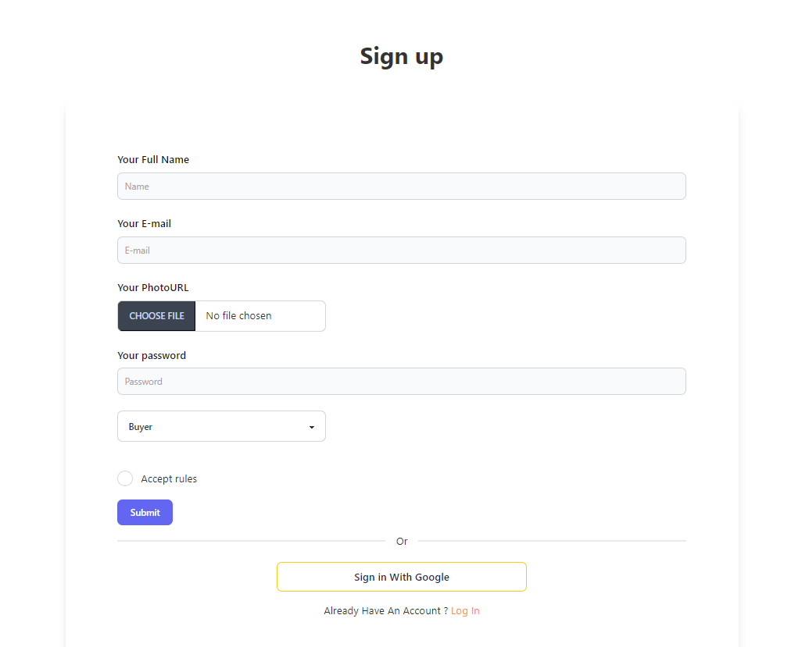

Sign in
Once you're signed up, you'll have access to a variety of features tailored to your needs. Whether you're a seller looking to reach a wider audience or a buyer searching for the perfect item, our platform provides the tools you need to succeed.
Already a member? Sign in to access your account and explore our platform's features. After signing in, you can easily sell your products or purchase items from our wide range of offerings. Enter your email address and password to securely log in and pick up where you left off. Whether you're managing your store or browsing for products, signing in allows you to seamlessly navigate our platform and enjoy a personalized experience. Join us now!"

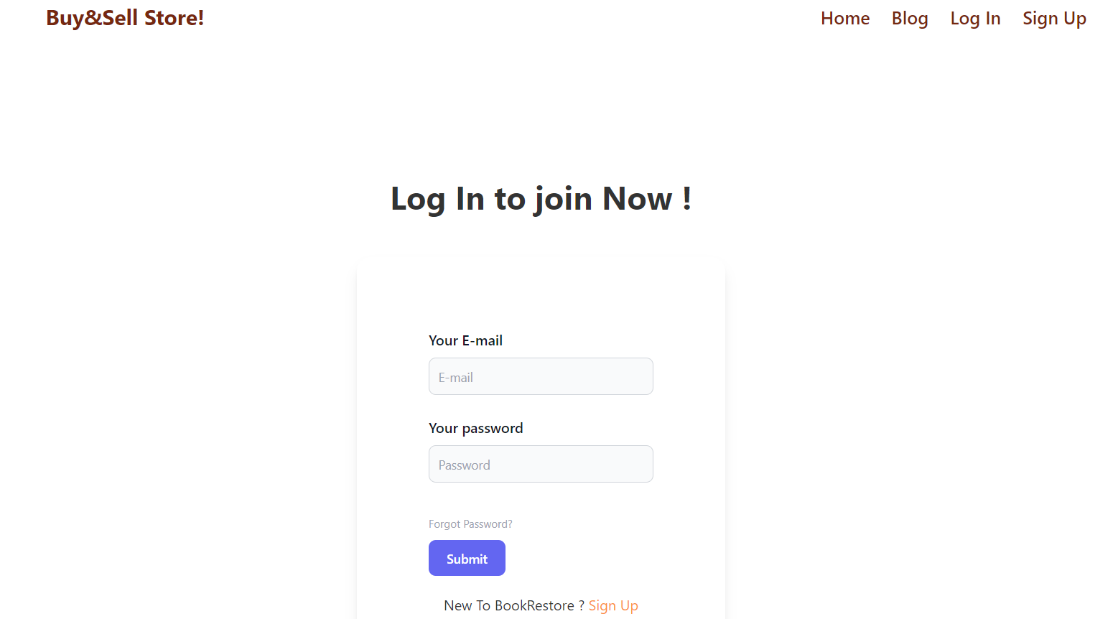

Seller:
Welcome to our online marketplace, where buying and selling are made simple! As a seller, you gain access to your personalized dashboard, designed to streamline selling experience. Within seller dashboard, you'll find three key options:
Add a Product: Ready to showcase your latest offerings, Use this feature to easily add new products to your store. Simply provide product details, upload images, and set pricing to attract potential buyers.
My Products: Keep track of your inventory and monitor product performance with ease. This section displays all listed products, delete the product and advertise the product on front page of the web application.
My Buyers: Curious about who's interested in your products, The My Buyers section provides a comprehensive list of customers who have purchased from your store.

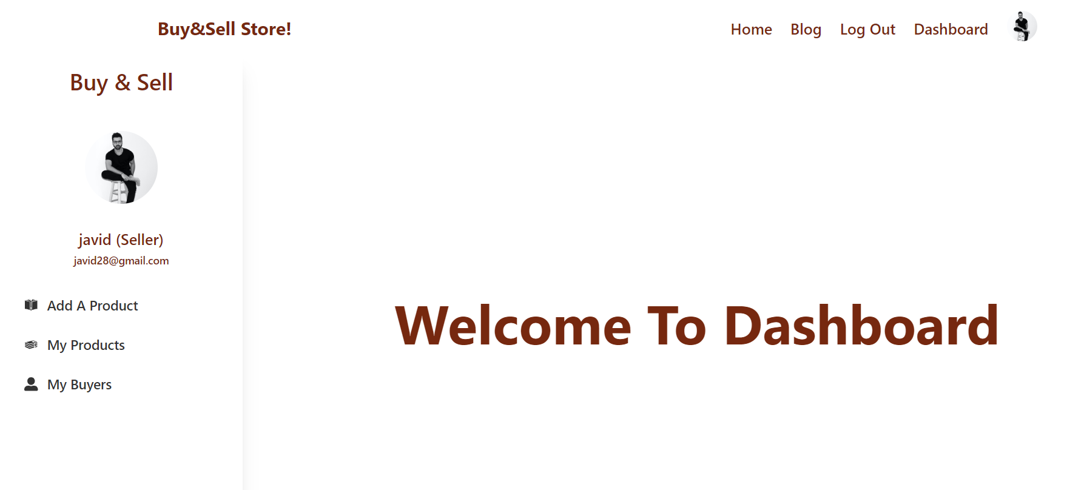
Add Product:
"Adding a product to our marketplace is a breeze! As a seller, you have the power to showcase your offerings to potential buyers with just a few simple steps. Here's how it works:
Product Details: Provide all the necessary information about your product, including its name, price, description, category, and any additional details that will help buyers understand its value.
Product Image: Capture the essence of your product by uploading clear and high-quality images. Visuals play a crucial role in attracting buyers.
Contact Information: Share your contact details, such as your phone number and location, so that buyers can easily reach out to you with inquiries or purchase requests.
Once you've filled in all the details, your product will be added to the main page, categorized according to its type. This means that buyers browsing our marketplace will have no trouble finding your product among the various categories available.
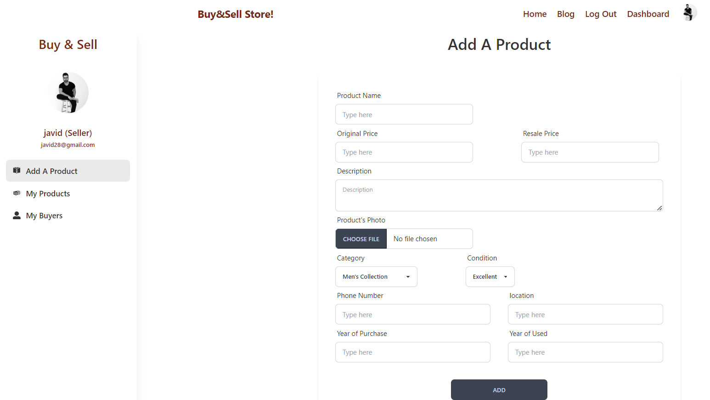
List of my products:
With the 'My Product' option, sellers gain convenient access to a comprehensive list of all the products they've previously uploaded or listed on our platform. Here's how it empowers sellers:
Product Management: Sellers can easily view and manage all their listed products in one centralized location. This includes details such as product name, price, category, and status.
Delete: Sellers have the option to remove products from the marketplace entirely. sellers have full control over their inventory.
Advertise: Want to give your product a boost in visibility? With the 'Advertise' option, sellers can promote their products to feature prominently on the first page of our website. This prime placement increases exposure and attracts more potential buyers.
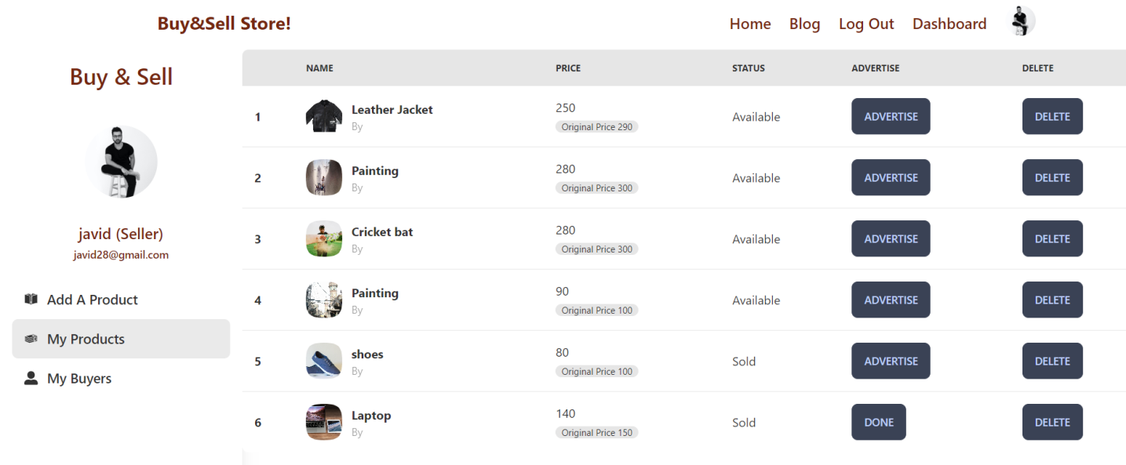

List of my buyers:

My Buyers:

With the help of My Buyer option seller can see list of his buyer those who make the booking of his products, seller can see buyer’s name, phone number, email, and location.

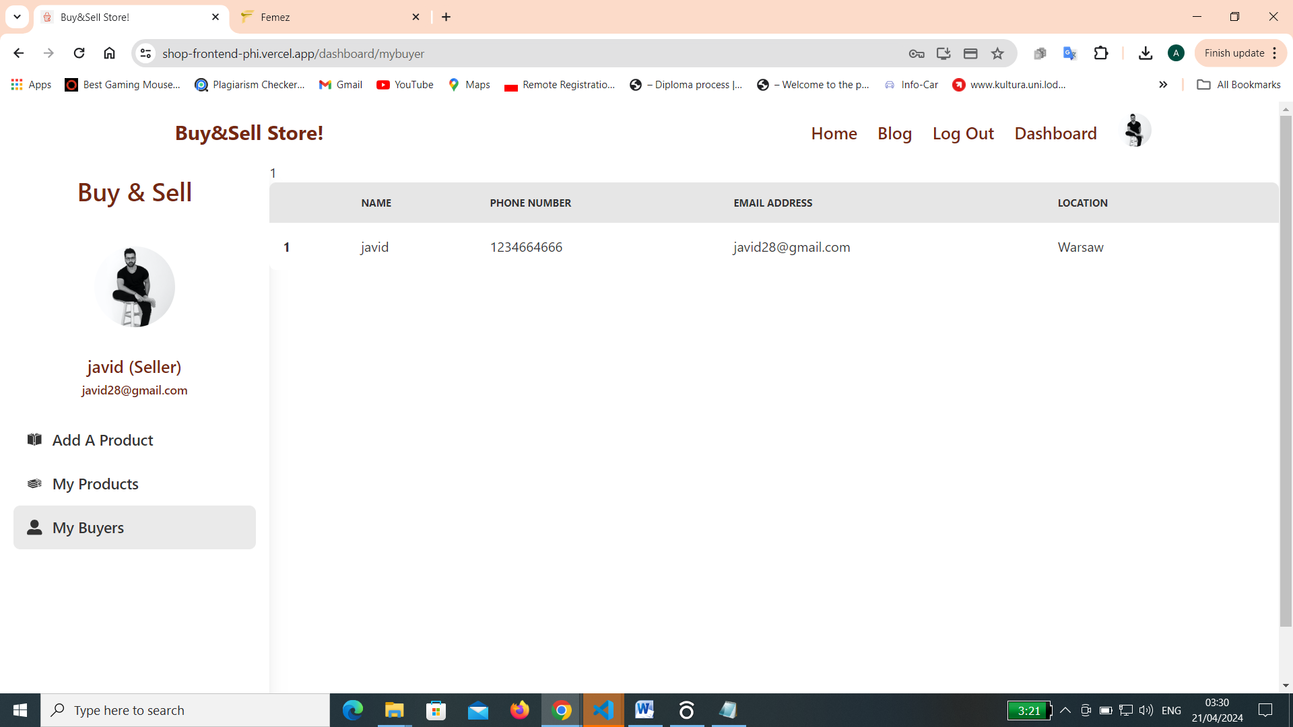

Buy a product or Report a Product (Buyer):

After logging in, buyers can explore and search for products across various categories. They can seamlessly purchase items using the 'Buy Now' feature, which supports secure online payment methods for convenience.
Additionally, buyers have the option to report any product they find concerning. This feature enables them to flag items that may violate policies or exhibit suspicious behavior, ensuring a safe and transparent marketplace environment.
Buyers can access detailed information about each product, including its original and retail prices. They also have visibility into the seller's profile, allowing them to review the seller's credentials and verify their authenticity. Verified sellers are identified with a checkmark next to their name, providing buyers with assurance regarding the seller's legitimacy.

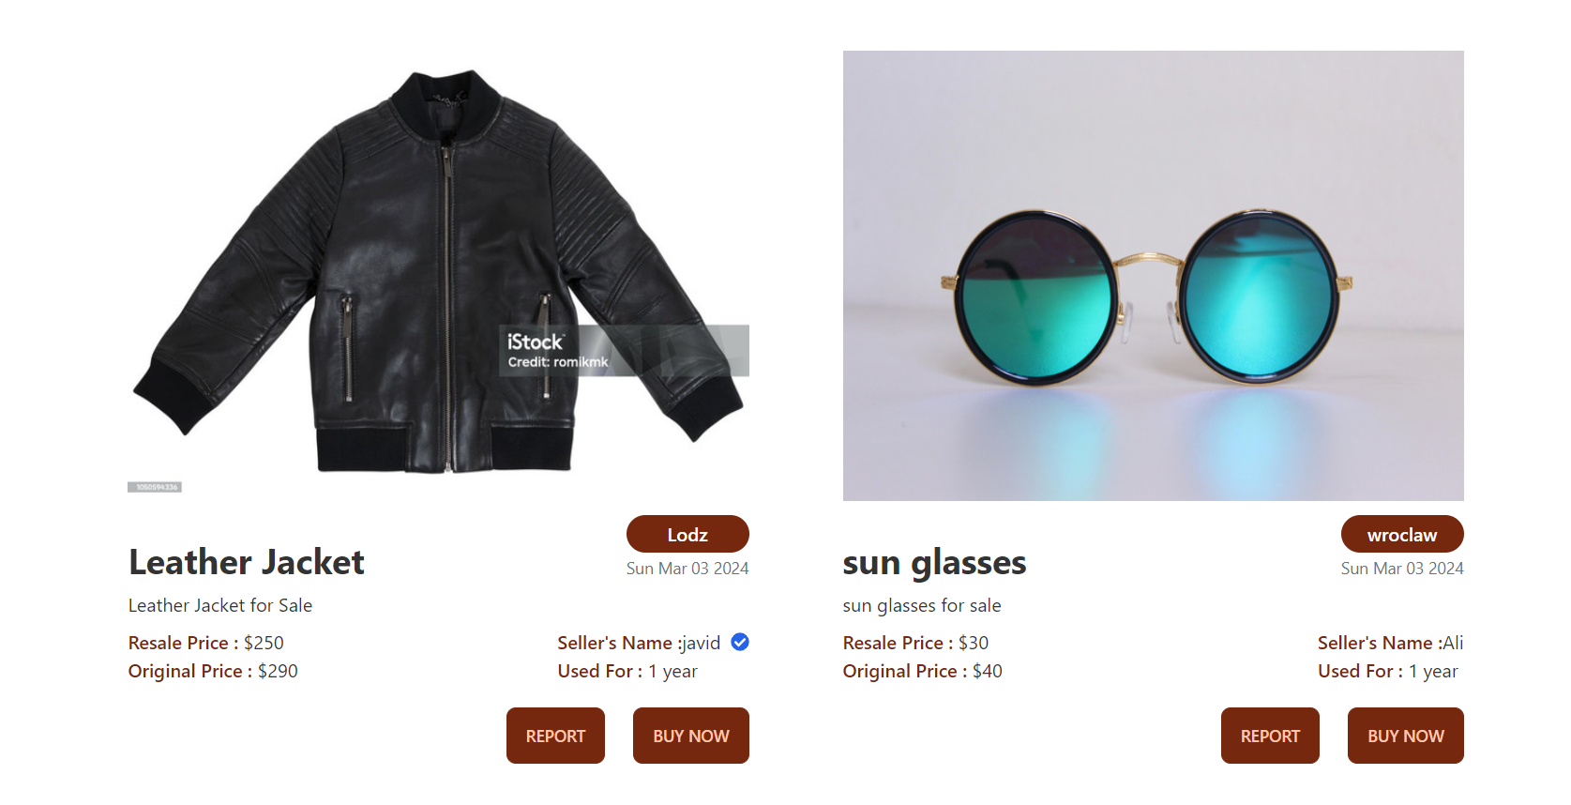

Buyer Dashboard

After selecting the 'Buy Now' option, buyers can easily reserve a product, initiating the booking process. Subsequently, buyers gain access to their personalized buyer dashboard, presenting a comprehensive list of all previously booked products.
Within this dashboard, each product entry is accompanied by pertinent details, including product images, pricing, and the seller's email address. Additionally, buyers are presented with an option to proceed with payment.
Upon selecting the 'Pay' option, buyers can securely input their credit card information to complete the transaction and finalize the purchase. Once the payment is successfully processed, the status of the product changes to 'Paid,' providing buyers with confirmation of their successful transaction.

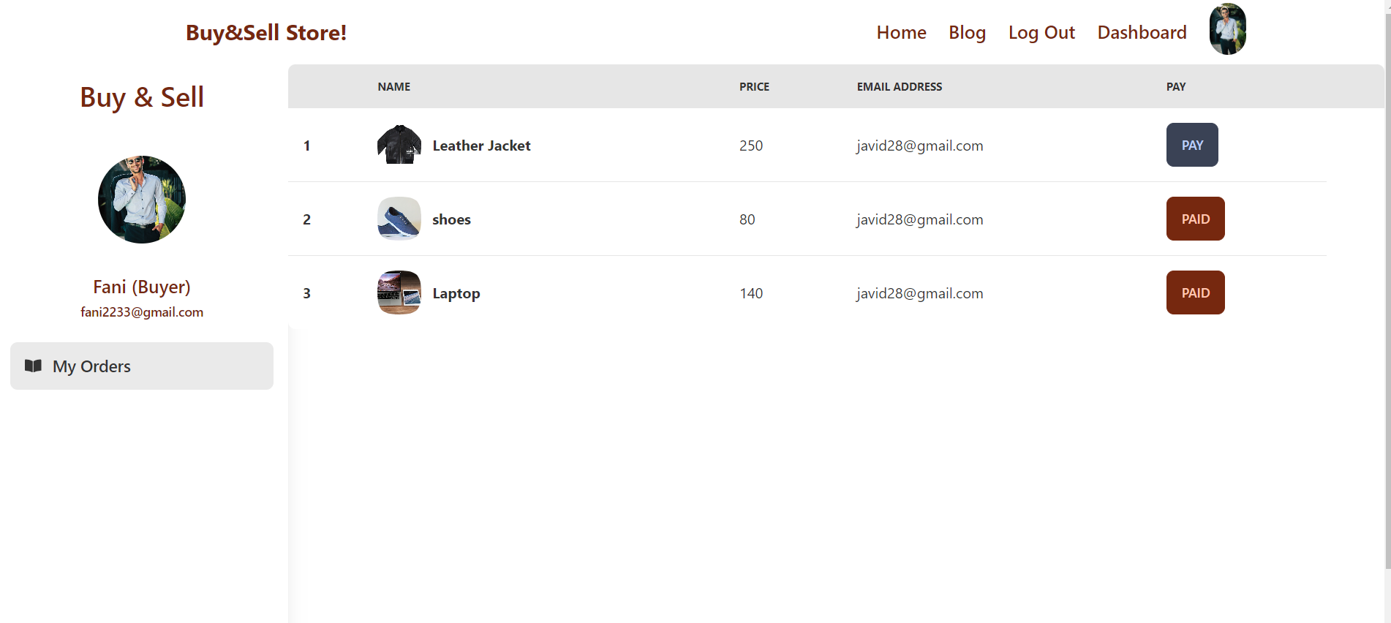

Admin (Dashboard) all sellers

After logging in, administrators gain access to the comprehensive admin dashboard, providing an overview of essential functions. Here, administrators can efficiently manage various aspects of the online platform, including overseeing sellers, buyers, and reported products.
Within the admin dashboard, administrators can seamlessly navigate through the 'All Sellers' section, which presents a detailed list of registered sellers. Each entry includes vital information such as the seller's name and email address. Additionally, administrators are empowered with the capability to verify sellers. By clicking the 'Verify' button, administrators can signify a verified seller status, denoted by a distinctive blue checkmark. This verification enhances transparency and instills trust among buyers. Furthermore, administrators can exercise control over seller accounts by utilizing the 'Delete' button, enabling the removal of seller profiles as needed.
The admin dashboard also offers visibility into the 'All Buyers' section, providing administrators with insights into the platform's buyer base. Similarly, administrators can monitor reported products through the dedicated 'Reported Products' option, allowing for prompt resolution of reported issues and ensuring the platform's integrity and security."

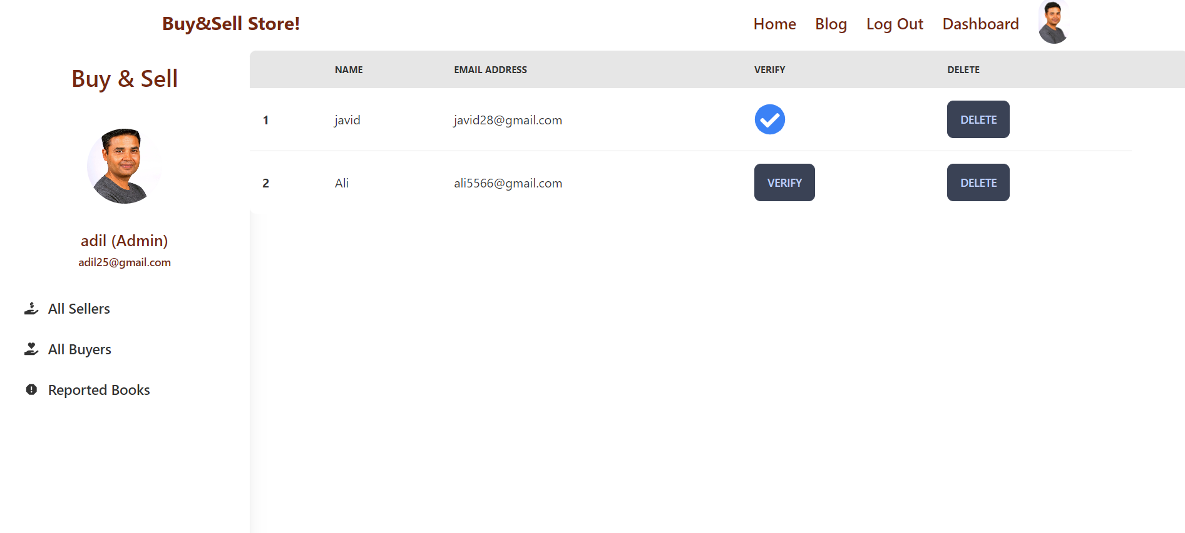

Admin all buyers

In the admin dashboard, administrators have access to a comprehensive overview of all buyers through the 'All Buyers' option. This feature enables administrators to efficiently manage the buyer base by providing essential information such as the buyer's name and email address.
Administrators can utilize the 'Delete' button associated with each buyer entry to remove buyer profiles as necessary. This functionality grants administrators the flexibility to maintain the integrity of the platform and manage buyer accounts effectively.

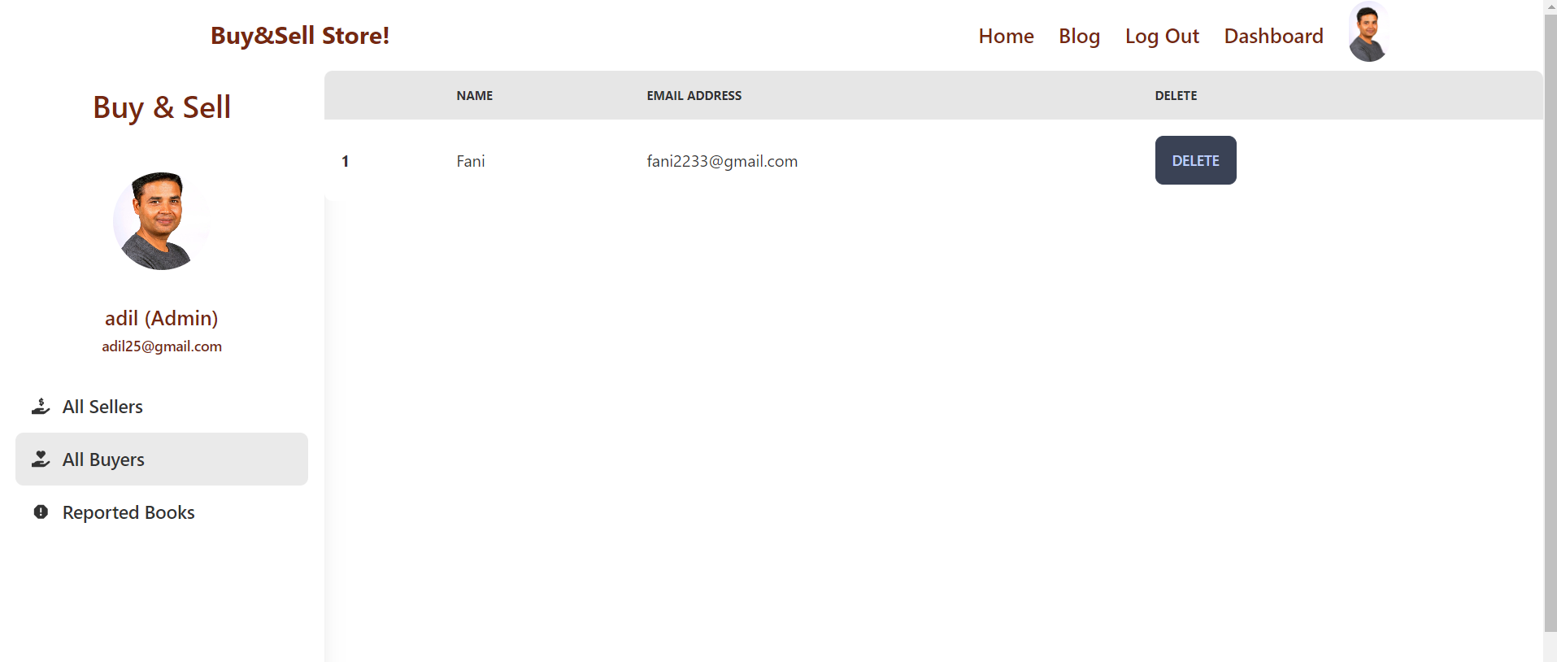

Reported items:

In the admin dashboard, administrator has access to the 'Reported Books' section, where he can view a list of reported products. This list provides detailed information about each reported product, including the product name, image, price, status, and seller's email address.
Additionally, administrator has the option to take action on reported products by utilizing the 'Delete' button associated with each entry. This functionality empowers administrators to efficiently manage reported products and maintain the quality and integrity of the platform.

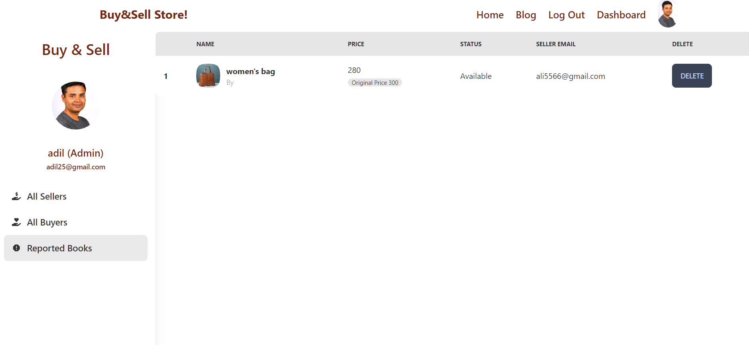

Bibliography

Books

- Joe Morgan, How to code in React.js, Digital Ocean, 2021.
- Chris Minnick, ReactJS Foundations, John Wiley & Sons, 2022.
- Sandro Pasquali, Mastering Node.js, Packt Publishing, 2013.
- David Gutman and Edited by Nate Murray, Fullstack Node.js, Fullstack.io, 2019
- KYLE BANKER, PETER BAKKUM, SHAUN VERCH, DOUGLAS GARRETT and TIM HAWKINS, MongoDB in Action, y Manning Publications Co, 2016.

Articles in professional journals
- Sumangla A. Bafna, Pratiksha D. Dutonde, Shivani S. Mamidwar, Monali S. Korvate, Prof. Dhiraj Shirbhare, Review on Study and Usage of MERN Stack for Web Development, International Journal for Research in Applied Science & Engineering Technology (IJRASET), journal number, publication 2022,
- Prof. Yogesh Kadam, Akhil Goplani, Shubit Mattoo, Shashank Kumar Gupta, Darshan Amrutkar, Prof. Dr. Jyoti Dhanke, Introduction to MERN Stack & Comparison with Previous Technologies, Article in European Chemical Bulletin, June 2023

Internet knowledge sources
- ReactJS, https://react.dev
- Node.js, https://nodejs.org
- MongoDB, https://www.mongodb.com/
- Vercel, https://vercel.com/
- Firbase, https://firebase.google.com/

Resources
- W3school, https://www.w3schools.com/
- stack overflow, https://stackoverflow.com/
- Youtube, https://www.youtube.com/
- React, https://legacy.reactjs.org/

